INFORMATION SECURITY
LAB 1 CLASS PARTICIPATION 1
CEASER CIPHER METHOD

PLAIN TEXT - > PAKISTAN
KEY -> 4
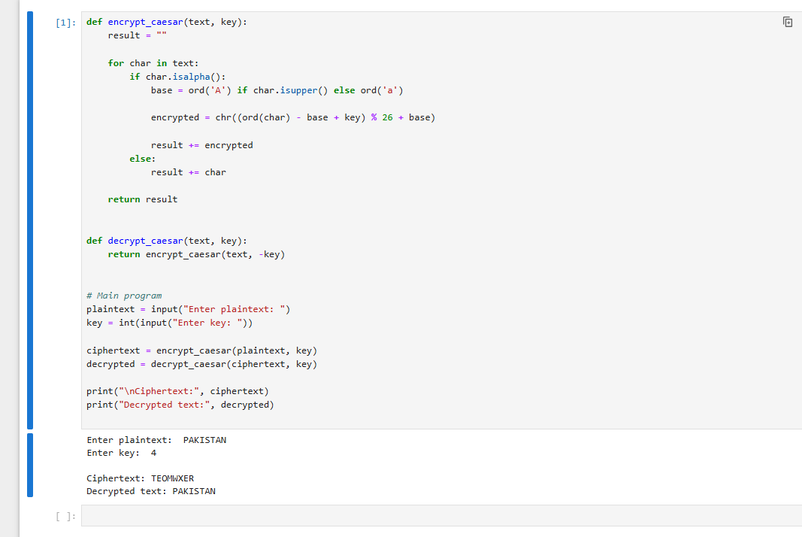

PLAIN TEXT - > TEACHER
KEY -> 3
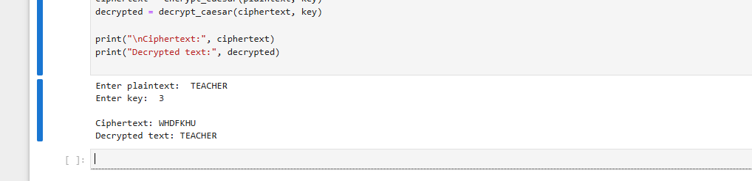

PLAIN TEXT - > ZAMAN
KEY -> 5
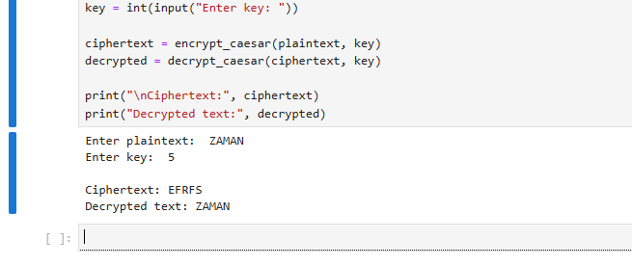

VIGENER CIPHER METHOD

PLAIN TEXT - > PAKISTAN
KEY -> BOX
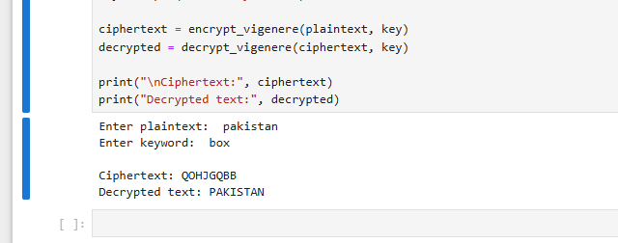

PLAIN TEXT - > TEACHER
KEY -> BOX
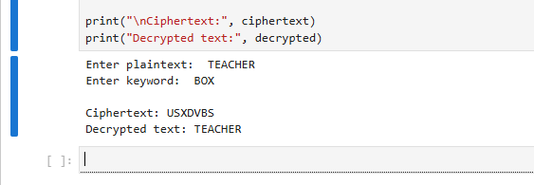

PLAIN TEXT - > ZAMAN
KEY -> BOX
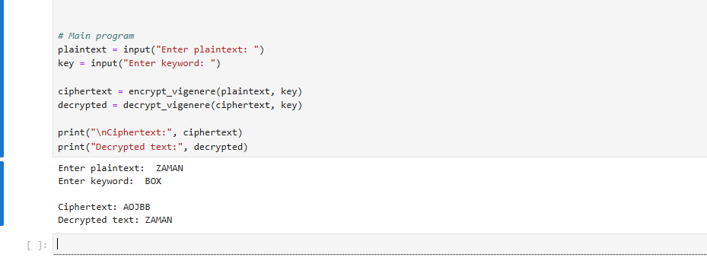

CLASS PARTICIPATION 1
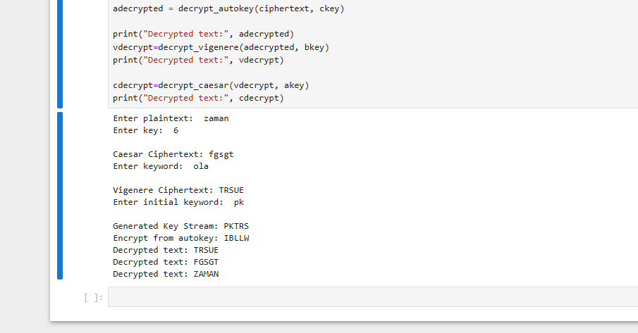
# Caesar cipher method

def encrypt_caesar(text, akey):
result = ""

for char in text:
if char.isalpha():
base = ord('A') if char.isupper() else ord('a')

encrypted = chr((ord(char) - base + akey) % 26 + base)

result += encrypted
else:
result += char

return result

def decrypt_caesar(text, akey):
return encrypt_caesar(text, -akey)

# Main program
plaintext = input("Enter plaintext: ")
akey = int(input("Enter key: "))

Aciphertext = encrypt_caesar(plaintext, akey)

print("\nCaesar Ciphertext:", Aciphertext)

# -> Vigenere cipher method

def encrypt_vigenere(plaintext, bkey):
result = ""
bkey = bkey.upper()

bkey_index = 0

for char in plaintext:
if char.isalpha():

p = ord(char.upper()) - ord('A')
k = ord(bkey[bkey_index % len(bkey)]) - ord('A')

encrypted = chr((p + k) % 26 + ord('A'))

result += encrypted

bkey_index += 1

else:
result += char

return result

def decrypt_vigenere(ciphertext, bkey):
result = ""
bkey = bkey.upper()

bkey_index = 0

for char in ciphertext:
if char.isalpha():

c = ord(char.upper()) - ord('A')
k = ord(bkey[bkey_index % len(bkey)]) - ord('A')

decrypted = chr((c - k) % 26 + ord('A'))

result += decrypted

bkey_index += 1

else:
result += char

return result

# Main program
plaintext = Aciphertext
bkey = input("Enter keyword: ")

bciphertext = encrypt_vigenere(plaintext, bkey)

print("\nVigenere Ciphertext:", bciphertext)

# -> Autokey cipher method

def encrypt_autokey(plaintext, ckey):
plaintext = ''.join(
char.upper() for char in plaintext if char.isalpha()
)

ckey = ''.join(
char.upper() for char in ckey if char.isalpha()
)

# Generate key stream
keystream = ckey

while len(keystream) < len(plaintext):
keystream += plaintext

# Make sure key stream is exactly the plaintext length
keystream = keystream[:len(plaintext)]

ciphertext = ""

for i in range(len(plaintext)):

p = ord(plaintext[i]) - ord('A')
k = ord(keystream[i]) - ord('A')

c = (p + k) % 26

ciphertext += chr(c + ord('A'))

return ciphertext, keystream

def decrypt_autokey(ciphertext, ckey):
ciphertext = ''.join(
char.upper() for char in ciphertext if char.isalpha()
)

ckey = ''.join(
char.upper() for char in ckey if char.isalpha()
)

plaintext = ""

for i in range(len(ciphertext)):

# Initial keyword
if i < len(ckey):
k = ord(ckey[i]) - ord('A')

# Previously recovered plaintext
else:
k = ord(plaintext[i - len(ckey)]) - ord('A')

c = ord(ciphertext[i]) - ord('A')

p = (c - k) % 26

plaintext += chr(p + ord('A'))

return plaintext

# Main program
plaintext = bciphertext
ckey = input("Enter initial keyword: ")

ciphertext, keystream = encrypt_autokey(plaintext, ckey)

print("\nGenerated Key Stream:", keystream)
print("Encrypt from autokey:", ciphertext)

adecrypted = decrypt_autokey(ciphertext, ckey)

print("Decrypted text:", adecrypted)
vdecrypt=decrypt_vigenere(adecrypted, bkey)
print("Decrypted text:", vdecrypt)

cdecrypt=decrypt_caesar(vdecrypt, akey)
print("Decrypted text:", cdecrypt)

